**1. What is the difference between truncate, delete, drop?**

Delete is a DML (Data Manipulation Language) command.

This command removes records from a table.

It is used only for deleting data from a table, not to remove the table from the database.

It can use where clause or not use it.

Truncate is similar to Delete, but this operation is a DDL (Data Definition Language) command.

It also deletes records from a table without removing table structure, but it doesn’t use the where clause.

The Drop command is another DDL (Data Definition Language) operation. But it is not used for simply removing data from a table; it deletes the table structure from the database, along with any data stored in the table.

**2. What are alias in MySQL?**

In MySQL, an Alias means a temporary name given to a table or a column. The purpose of Aliases is to make table or column names more readable. The Aliases are more useful when multiple columns or multiple tables are used in a single query. Also, if the table names or column names are big or not readable. The AS keyword is used to define the Alias in SQL statement.

**3. How do you display even rows of the any table?**

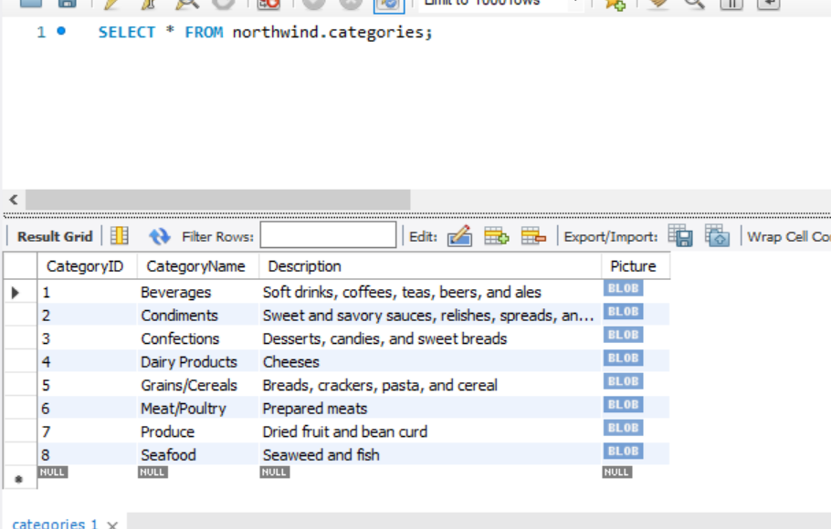

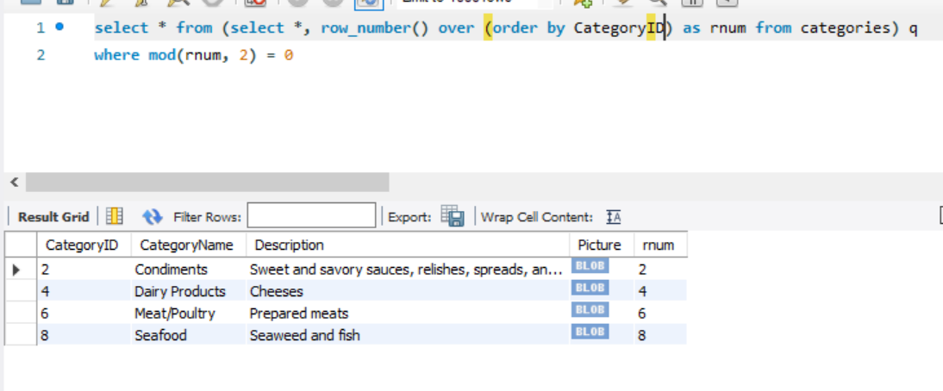

**4. How can you remove duplicates from a table(distinct and other way)?**

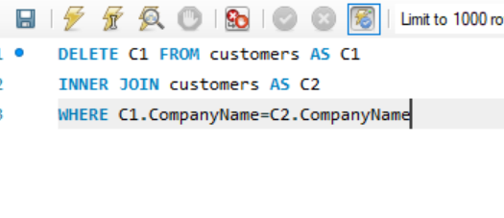

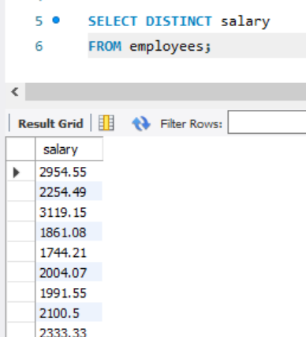

**5. How you can find 5th max salary?(Do it by all 3 ways)**

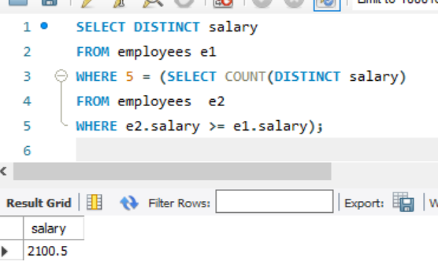

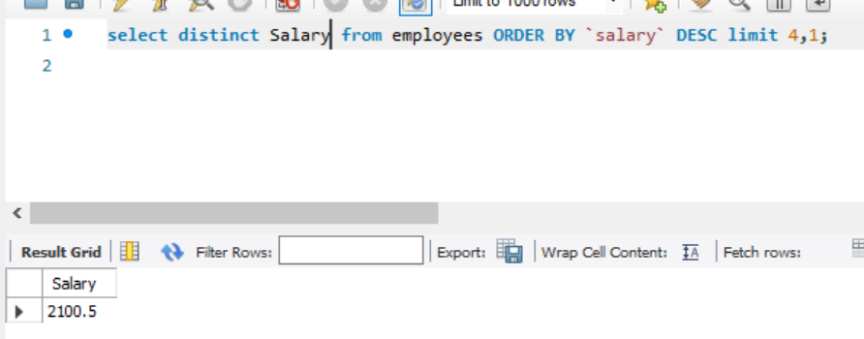

**3rd way**

select * from(select ename, sal, dense_rank() over(order by sal desc)r from Employee) where r=5